Introduction

A Dynamic Link library (DLL) is a library that contains functions and codes that can be used by more than one program at a time. Once we have created a DLL file, we can use it in many applications. The only thing we need to do is to add the reference/import the DLL File. Both DLL and .exe files are executable program modules but the difference is that we cannot execute DLL files directly.

Creating DLL File

**Step 1**- Open Visual Studio then select "File" -> "New" -> "Project..." then seelct "Visual C#"  -> "Class library".

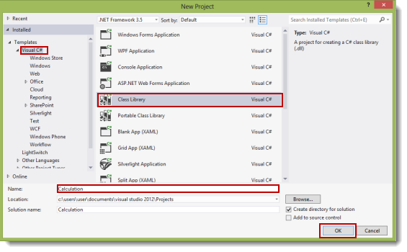

(I give it the name "Calculation".)

**Step 2**-Change the class name ("class1.cs") to "calculate.cs".

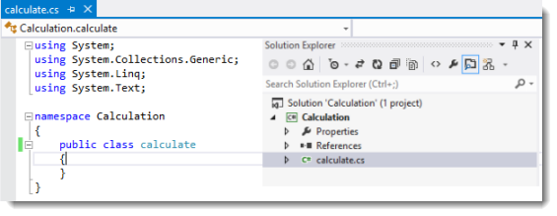

**Step 3**- In the calculate class, write methods for the addition and subtraction of two integers (for example purposes).

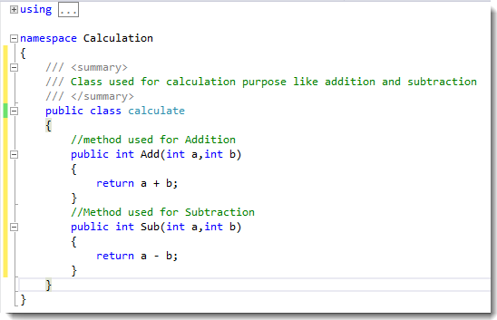

**Step 4**- Build the solution (F6). If the build is successful then you will see a "calculation.dll" file in the "bin/debug" directory of your project.

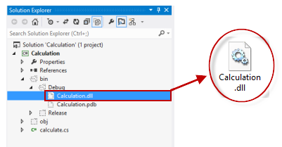

We have created our DLL file. Now we will use it in another application.

Using DLL File

**Step 1**- Open Visual Studio then select "File" -> "New" -> "Project..." then select "Visual C#"  -> "Windows Forms application".

**Step 2**- Design the form as in the following image:

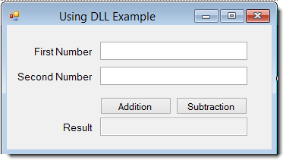

**Step 3**- Add a reference for the dll file, "calculation.dll", that we created earlier. Right-click on the project and then click on "Add reference".

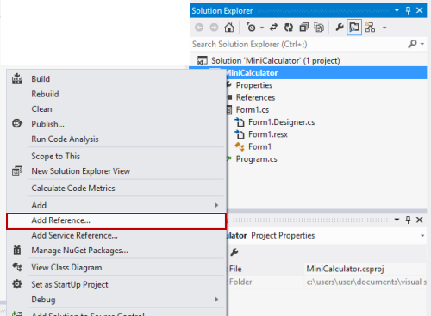

**Step 4**- Select the DLL file and add it to the project.

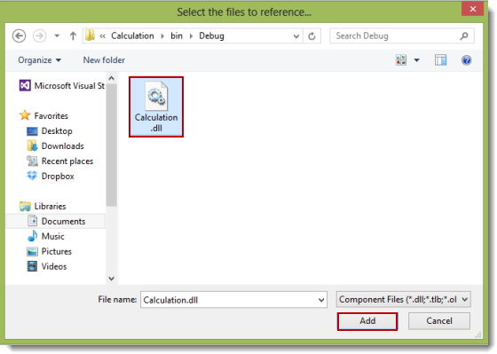

After adding the file, you will see that the calculation namespace has been added (in references) as in the following:

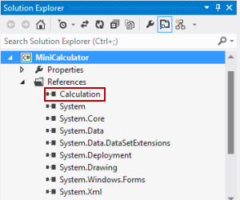

**Step 5** - Add the namespace ("using calculation;") as in the following:

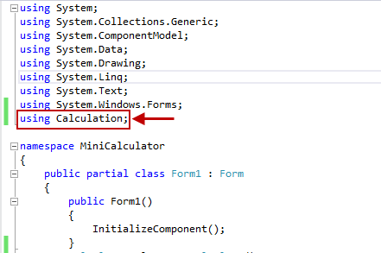

**Step 6**

1. **using** System;
2. **using** System.Collections.Generic;
3. **using** System.ComponentModel;
4. **using** System.Data;
5. **using** System.Drawing;
6. **using** System.Linq;
7. **using** System.Text;
8. **using** System.Windows.Forms;
9. **using** Calculation;
11. **namespace** MiniCalculator
12. {
13. **public** partial **class** Form1 : Form
14. {
16. **public** Form1()
17. {
18. InitializeComponent();
19. }
20. calculate cal = **new** calculate();
21. //Addition Button click event
22. **private** **void** button1_Click(**object** sender, EventArgs e)
23. {
24. **try**
25. {
26. //storing the result in int i
27. **int** i = cal.Add(**int**.Parse(txtFirstNo.Text), **int**.Parse(txtSecNo.Text));
28. txtResult.Text = i.ToString();
29. }
31. **catch** (Exception ex)
32. {
33. MessageBox.Show(ex.Message);
34. }
35. }
37. //Subtraction button click event
39. **private** **void** button2_Click(**object** sender, EventArgs e)
40. {
41. Try
42. {
43. //storing the result in int i
44. **int** i = cal.Sub(**int**.Parse(txtFirstNo.Text), **int**.Parse(txtSecNo.Text));
45. txtResult.Text = i.ToString();
46. }
47. **catch** (Exception ex)
48. {
49. MessageBox.Show(ex.Message);
50. }
51. }
52. }
53. }